Lab No-**02**

Name of the lab: **Linux Command**

Name: **Arafat Islam** ID: **IT-17008**

***Objective:***

Linux is a Unix free operating system for computer devices. Linux is an special type operating system which makes the hardware work together with the software .This commands are writing in the shell command line which is also called a terminal emulator. These are given below:

***Our first linux commands***

1. *ls*
2. *pwd*
3. *cd*

***The basic commands***

*(4)df*

*(5)mkdir*

*(6) whoami*

*(7) hostname*

*(8) ls –a*

*(9)cd ..*

*(10)cd .. ..*

**Varies types of Linux command and their proper use are given below:**

**1.ls:** Ls stands of shorts of list. ls lists the files in the current working folder.

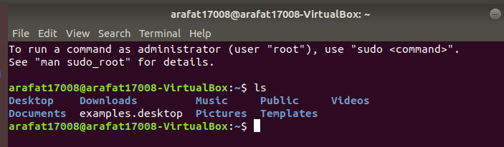

**2.whoami:** This command prints the username associated with the current effective user ID.

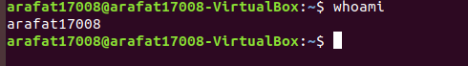

**3.hostname:** The hostname command shows or sets the system hostname.

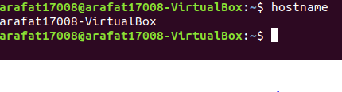

**4.pwd:** hort for **print working directory**, **pwd** is a Linux, Unix, and FTP command to print the directory you're currently working in when at the command line.

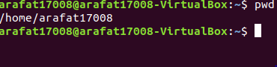

**5.ls –a:** list all files including hidden file starting with

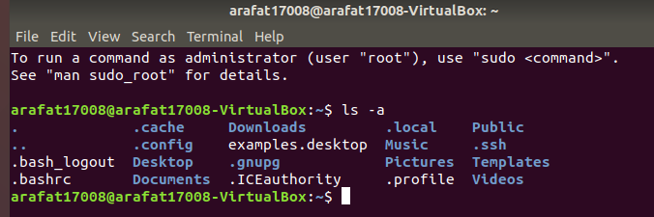

**6.cd:** The cd command, which stands for "change directory", changes the shell’s current working directory .

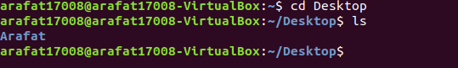

**7.mkdir:** The mkdir command creates new directories in your file system.

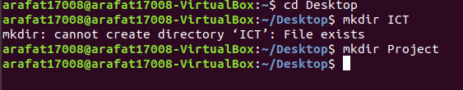

**8.cd .. :**Move one directories up.

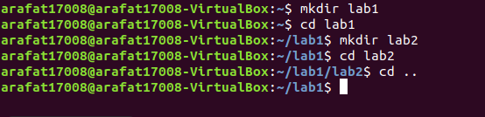

**9:cd .. .. :** Move two directories up.

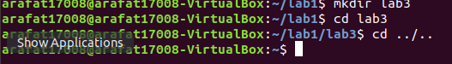

**10.df:** view filesystem disk space usage

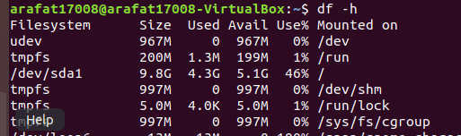

***Discussion:***

The linux operating system are used widely. From this lab, I learnt how to run a linux operating system by using linux command.This lab is very interesting .